**Sum of Natural numbers**

Given a number n, find the sum of first natural numbers.

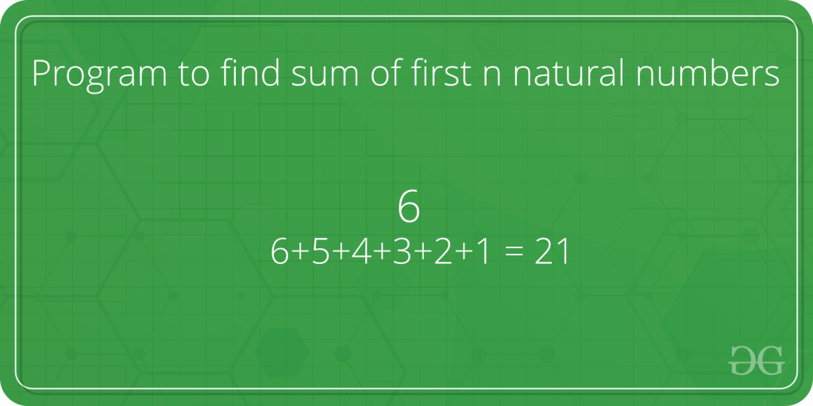

**Examples :**

Input : n = 3

Output : 6

Explanation :

Note that 1 + 2 + 3 = 6

Input : 5

Output : 15

Explanation :

Note that 1 + 2 + 3 + 4 + 5 = 15

A **simple solution** is to do the following.

1) Initialize : sum = 0

2) Run a loop from x = 1 to n and

do following in loop.

sum = sum + x

C++

// CPP program to find sum of first

// n natural numbers.

#include <iostream>

using namespace std;

// Returns sum of first n natural

// numbers

int findSum(int n)

{

int sum = 0;

for (int x = 1; x <= n; x++)

sum = sum + x;

return sum;

}

// Driver code

int main()

{

int n = 5;

cout << findSum(n);

return 0;

}

**Output**

**15**

***Time Complexity:****O(n)*

***Auxiliary Space:****O(1)*

An **efficient solution** is to use the below formula.

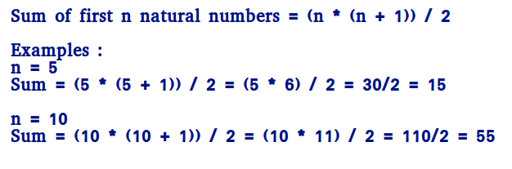

**How does this work?**

**We can prove this formula using induction.**

**It is true for n = 1 and n = 2**

**For n = 1, sum = 1 * (1 + 1)/2 = 1**

**For n = 2, sum = 2 * (2 + 1)/2 = 3**

**Let it be true for k = n-1.**

**Sum of k numbers = (k * (k+1))/2**

**Putting k = n-1, we get**

**Sum of k numbers = ((n-1) * (n-1+1))/2**

**= (n - 1) * n / 2**

**If we add n, we get,**

**Sum of n numbers = n + (n - 1) * n / 2**

**= (2n + n2 - n)/2**

**= n * (n + 1)/2**

C++

// Efficient CPP program to find sum of first

// n natural numbers.

#include<iostream>

using namespace std;

// Returns sum of first n natural

// numbers

int findSum(int n)

{

return n * (n + 1) / 2;

}

// Driver code

int main()

{

int n = 5;

cout << findSum(n);

return 0;

}

**Output**

**15**

***Time Complexity:****O(1)*

***Auxiliary Space:****O(1)*

**The above program causes overflow, even if the result is not beyond the integer limit**. We can avoid overflow up to some extent by dividing first.

C++

// Efficient CPP program to find sum of first

// n natural numbers that avoids overflow if

// result is going to be within limits.

#include<iostream>

using namespace std;

// Returns sum of first n natural

// numbers

int findSum(int n)

{

if (n % 2 == 0)

// Here multiplying by 1LL help to

// perform calculations in long long,

// so that answer should not be overflowed

return (n / 2) * 1LL * (n + 1);

// If n is odd, (n+1) must be even

else

// Here multiplying by 1LL help to

// perform calculations in long long,

// so that answer should not be overflowed

return ((n + 1) / 2) * 1LL * n;

}

// Driver code

int main()

{

int n = 5;

cout << findSum(n);

return 0;

}

**Output**

**15**

***Time Complexity:****O(1)*

***Auxiliary Space:****O(1)*